zPeriod 136 Teaching date: May 05th , 2026
Review 4
Parts 1, 2
A. OBJECTIVES:
By the end of the lesson, Ss will be able to:
1. Knowledge:
- correctly use the following sentence patterns:
+What was the weather like last weekend? – It was …….
+Do you want to go to the ……….? – Great! Let’s go. / Sorry, I can’t.
+What does it say? – It says ʽ…………ʼ.
+How can I get to the ………? – ……….
+Where’s the bookshop? – It’s …………
+How much is the ………..? – It’s ……..
+What are these animals? – They’re ………..
+Why do you like ………..? – Because they ……….
+What's he / she doing? – He's / She's ………..
+What are they doing? – They’re ……….
- Vocabulary: Review
- Skills: speaking, listening, reading and writing.
2. Competences:
- Co-operation: ready to help friends in pair work/ group work.
- Self-control and independent learning: perform listening tasks.
3. Attitude/ Qualities:
- Kindness: Help partners to complete learning tasks.
- Honesty: tell the truth about feelings and emotions.
B. TEACHING AIDS:
- Teacher: Teacher’s guide Pages 293, 294; Track 102; website hoclieu.vn, posters, laptop, pictures, textbook, lesson plan, TV or projector.
- Students: Pupil’s book Page 70, notebooks, workbooks, school things.
C. PROCEDURES:
Teacher’s activities | Students’ activities
1.Warm- up: (5’)  Game: Choose and throw  *Aims: to review the vocabulary and structure about greet and respond to greetings.  *Procedure:  - Divide class into 2 teams.  - Call 1 pupil from each team to come to the board and throw a sticky ball at the answer.  - Teacher marks the place where they throw it.  - Teacher reveals the score for the correct answer.  - Say “Open your book page 70” and look at Review 4.  2.Practice: (27)  Activity 1. Listen and tick:  *Aims: Ss will be able to listen to and understand five communicative contexts in which characters talk about familiar topics such as weather, directions, items price, animals and camp activities and tick the correct pictures.  *Procedure:  - Elicit the words or phrases to describe the pictures in each option.  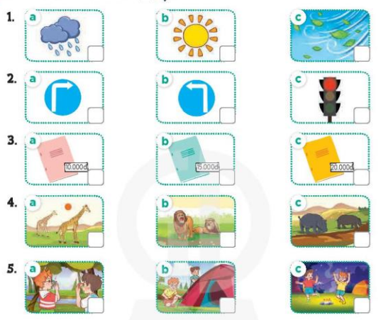  - T ask Ss to guess the answers.  + T writes Ss’guessing on the board.  - Listen to the tape:  + Play the recording  + Play the recording again and get Ss to swap books with their partners.  + Play the recording again to check answers together as a class.  + Write the answers on the board for Ss to correct their answers. Then checks Ss’ guessing.  - Play the recording, sentence by sentence, for the class to listen and repeat in chorus.  Key: 1. b 2. a 3. b 4. c 5. b  Activity 2. Ask and answer  *Aims: Ss will be able to ask and answer questions using picture cues.  *Procedure: https://wayground.com/admin/quiz/6a19b6824e9dc975dcb3d385  https://wayground.com/admin/assessment/6a19c038b64727794eed7975?source=lesson_share  - Elicit the answer and give feedback.  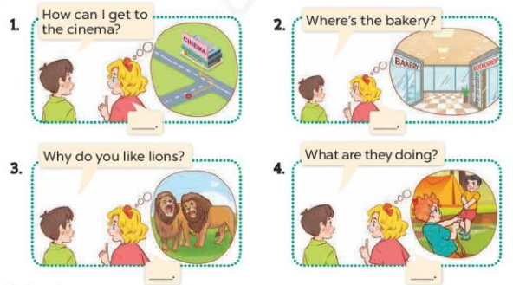  - Get Ss to role-play the exchange. Repeat the same procedure with the rest of the questions.  - Give Ss time to take it in turns to role-play the four exchanges.  - Invite pairs of Ss to stand up and take it in turns to role-play the target exchanges.  *Consolidation  *Aims: Ss will be able consolidate and wrap up the content of the lesson.  *Procedure:  - T asks ss to answer the following questions:  + What have you learnt from the lesson today?  - T praises some Ss who are hardworking / active/ good…. as well as encourage others to try more.  4. Homework. (3’)  - Prepare the new lesson: Review 4 (3,4,5) | - Ss listen  -Ss play game  - Ss open their books  -Look at the pictures and say  1a. a rainy icon  1b. a sunny icon  1c. a windy icon  2a. a ʽturn rightʼ road sign  2b. a ʽturn leftʼ road sign  2c. a ʽstopʼ road sign  3a. a notebook and a price tag: 10,000 dong  3b. a notebook and a price tag: 15,000 dong  3c. a notebook and a price tag: 20,000 dong  4a. Two giraffes  4b. Two lions  4c. Two hippos  5a. Two boys taking a photo  5b. Two boys putting up a tent  5c. Two boys dancing around the campfire  -Ss guess the answers  - Ss listen to the tape and tick  - Ss listen again, tick and swap books with their partners.  - Ss check their answers and guessing  -Ss listen and repeat.  -Look at the pictures and say  -Ss role-play with the rest of the question  - Ss role-play the four exchanges  - Ss stand up and take it in turns to role-play.  -Ss listen and answer  -Ss listen and clap their hands  -Ss listen and take note
D. ADJUSTMENTS (if necessary):
………………………………………………………………………………………….…..……………………………………………………………………………...…………

